Pokemon Beep

Contents

Gym Leader 3

Undefined 4

Swift 5

Pascal 6

Ruby 7

Shell 8

Crystal 9

Python 10

Dart 11

Cities 12

Plankalkül Town 13

Artificial Intelligence 14

Wild Pokémon 15

# Gym Leader

## Undefined

Type:

Gym: Corrupted Pokémon Gym

Description:

Undefined is a corrupted Gym Leader. There is no way the player can understand it except if it knows how to decode it.

Speciality:

* All trainers will complain about errors they had using different code languages.
* The Gym Leader’s text will be crypted.
* The Gym Leader’s Pokemon will uses randomized color.
* The Gym Leader will use a Legendary Pokemon named “MissingNo”.
* The Gym battle theme will be very buggy.

## Swift

Type:

Gym: Apple Store

Description:

Swift is an Apple Store manager. He thinks Apple is the best OS and Android is inferior in every way. Your typical Apple normie.

Speciality:

* All the trainers are employees of the Apple Store.
* There are non-trainer NPC in the Gym looking to buy Apple Product (They are saying normies stuff).

## Pascal

## Ruby

Type:

Gym: Traditional Shrine

Description:

Ruby is a Japanese gym leader. He is the owner of the shrine.

Speciality:

* All the Pokémon’s name will be in Japanese.
* Luka (Stein’s gate) will be a trainer in the Gym

## Shell

## Crystal

## Python

## Dart

# Cities

## Plankalkül Town

Description: Plankalkül Town is a small undeveloped German town stuck in 1950. Peoples here are very traditional, and the town is VERY BORING. You character want to get out of this town at all cost!

Story:

Inspiration: Plankalkül is the first high-level programming language.

Characteristics:

* 4 houses
* 7 NPCS (2 inside 5 outside)

Once you get your first badge, if you talk to the fisherman, he will give you an old rod.

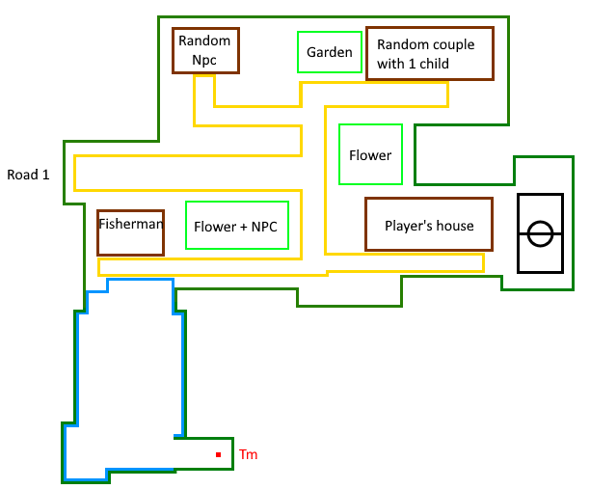

## City 2

Description: City is a small city with a bit more advanced technology than Plankakul.

Story:

Inspiration: Plankalkül is the first high-level programming language.

Characteristics:

* 4 houses
* 7 NPCS (2 inside 5 outside)

Once you get your first badge, if you talk to the fisherman, he will give you an old rod.

# Artificial Intelligence

## Wild Pokémon

If the player’s Pokemon has 10 % or less, the Wild Pokemon will try to use a priority move that deal damage. If it does not have any priority move, he will try to use a damaging move. If it does not have any of those, it will simply do a random between 1 and the number of moves it has.